Volker, Peter William, Dr (from Linked In)
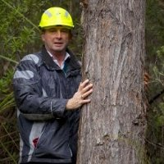

BSc (Forestry) ANU 1978 – 1981. GradDipSc (Forestry), First Class ANU 1988 – 1989, University of Tasmania, PhD, Forest genetics 1993 – 2002University of Tasmania, MBA (Environmental Management)2012 – 2013Thesis title: Quantitative genetics of Eucalyptus nitens, E. globulus and their F1 hybrid.

Forester Tasmania Forestry Commission 1981 – 1985. Forest Scientist CSIRO 1986 –1990. Forest Manager Australian Newsprint Mills Ltd 1990 –1997. Forestry Consultant Serve Ag Pty Ltd 1997 –2000. Managing Director Total Sylvan Enterprises 2000 – . Principal Research Scientist, Plantations Forestry Tasmania 2002 –2008. Manager, Field Services Forestry Tasmania 2007 –. Chairman PlantPlan Genetics Pty Ltd 2009 – . Director Southern Tree Breeding Association Inc. 2009 – .

National President Institute of Foresters of Australia October 2005 – November 2011. Fellow of Institute of Foresters of Australia, Registered Professional Forester with specialist expertise in forest genetics and silviculture.

Captain of Tasmania Golf Club, 1994 – 2002. Rowing Australia (Australian Sports Commission) , Rowing Coach 2001. ANU Australian Football Club, ANU Rowing Club, ANU Forestry Students Society (Social Secretary).

